Picosecond Ion Pulses from an EN Tandem Created by a Femtosecond Ti:Sapphire Laser

K.D. Carnes, C.L. Cocke, Z. Chang, I. Ben-Itzhak, H.V. Needham, and A. Rankin

James R. Macdonald Laboratory
Department of Physics
Kansas State University
Manhattan, Kansas 66506

As the James R. Macdonald Laboratory at Kansas State University continues its transformation from an ion collisions facility to an ultrafast laser/ion collisions facility, we are looking for novel ways to combine our traditional accelerator expertise with our new laser capabilities. One such combination is to produce picosecond pulses of stripping gas ions in the high energy accelerating tube of our EN tandem by directing ~100 femtosecond, sub-milliJoule laser pulses up the high energy end of the tandem toward a focusing mirror at the terminal. Potential ion pulse broadening effects, such as tandem terminal ripple, thermal motion of the gas, and space charge will be discussed. SIMION calculations showing the effect of Dowlish titanium spiral inclined field tubes on the pulses will be presented, along with a report on the current status of the project.

1. Introduction

In 2001, the James R. Macdonald Laboratory embarked on a new phase of its research mission by installing an ultrafast, intense titanium sapphire laser system. Since that time, the emphasis of the laboratory’s research has shifted from primarily ion-atom and ion-molecule collisions to the study of dynamical processes involving ions, atoms, molecules, surfaces, or nanostructures exposed to short, intense bursts of electromagnetic radiation. As a result, we have developed considerable expertise in both accelerator-based and laser-based physics. With the encouragement of our funding agency, the Department of Energy, it seemed worthwhile to try and combine those areas of expertise in some of our projects. We therefore have been developing a source of narrow ion bunches, on the order of 10’s of picoseconds in width, by using our femtosecond, intense laser beam to ionize stripping gas in our EN Tandem van de Graaff. The resulting energetic, narrow bunches of ions could find use in such areas as time-dependent charged particle diffraction [1,2], where the greater penetrating power and smaller de Broglie wavelength of a light ion would be beneficial. Very narrow time bunches of ions would also alleviate some of the duty cycle mismatch between ion and laser beam pulses that make laser-assisted charge transfer collisions so difficult to study experimentally [3,4].

2. Construction Details

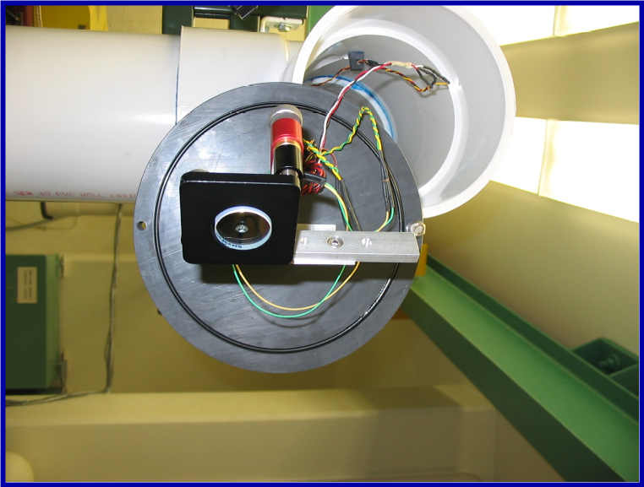
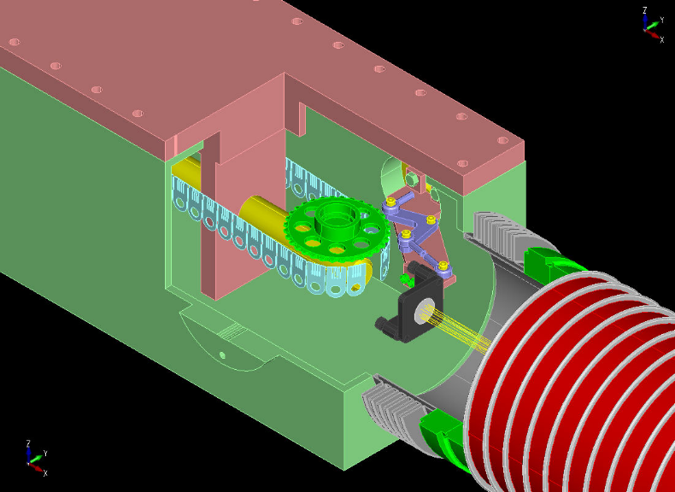
Our experience in delivering ion beams to various target areas in the laboratory has stood us in good stead in developing a distributed laser transport system. From a central laser room, the pulsed laser beam is already delivered to several experiments throughout the laboratory. It was therefore relatively straightforward to bring the beam to the tandem. In the future, we will want to have two parallel beams from the laser room, one to ionize the gas inside the tandem, and another to use as a “probe” beam to interact with the ions. Our technical staff therefore used a nominal 6” diameter standard PVC “sewer” pipe to construct the transport line. The pipe is large enough to transport the two laser beams in parallel, and the PVC joints are sufficient to maintain a milliTorr range mechanical pump vacuum, necessary to prevent excessive dispersion of the laser pulse over 10’s of meters of travel. We used dielectric mirrors from Layertech mounted in New Focus piezoelectric motor drive mirror mounts for bending the laser beam around several corners. The position of the beam on the mirrors was monitored by infrared cameras mounted on small circuit boards inside the transport pipe. Video monitors near the remote mirror motor controls allow for straightforward tuning of the beam. A small optical table has been mounted on the 90 degree analyzing magnet stand which supports a mirror, irises, and a variable neutral density filter to control the power and position of the laser beam as it enters the beamline through a quartz window on the zero degree port of the analyzing magnet. Finally, a camera mounted at the low energy end of the tandem allows us to see the fluorescence of the laser beam as it emerges from a quartz window at the zero degree port of the inflection magnet after our two negative ion sources. We have found the initial alignment of the laser through the tandem, including through the stripping canal, to be straightforward, usually taking less than an hour of tuning.
Figure 1: Mirror in motorized mount.
Figure 2: Focusing mirror inside stripper box.
The focusing mirror was installed inside the stripper box at the terminal of the tandem (see Figure 2). A linear motion feedthrough was mounted on an unused preexisting port of the box and powered by a Georator already used to power the terminal leak and a recirculating turbo pump. The feedthrough operates a gear assembly that either extends the mirror into the path of the laser beam or folds it back out of the way for standard tandem operation. An external switch activates the mechanism via a string inside the tandem. This drive mechanism has so far proven to be reliable and easy to operate.

3. Limitations on Achievable Pulse Widths

Several factors limit the minimum temporal pulse width we can achieve with the current configuration of our EN tandem. Our initial goal is to achieve these limits before affecting any major changes in the accelerator to further reduce the time spread. In the calculations that follow, a test case of helium stripping gas with 3 MV on the tandem terminal will be used, since it is likely that some of our first experiments will involve helium ions. Our laser beam has a 790 nm central frequency, and we currently use a 25 cm focusing mirror, which means that the focal point is approximately 20 cm into the third accelerating tube. Given a 1 cm diameter of the unfocused laser beam, the radius of the beam (where its intensity drops to 1/e²) at the focus is 12.4 μm and the Rayleigh range is .62 mm. The ion time-of-flight is measured at a detector 6.2 m downstream from the exit of the final tandem acceleration tube.

3.1 Thermal spread

At room temperature, the ½kT energy of the stripping gas along the beam direction is ~13meV. This corresponds to a time jitter of about ±40 ps for He.

3.2 Laser focal volume (extended source)
confocal parameter
beam waist (2×1/e² radius)

The length of the focal volume along the beam is generally taken to be the confocal parameter, or twice the Rayleigh range (See Figure 3). The effect of this extended source can be removed by setting the drift length of the ions to twice the acceleration length. For the particular position of our detector, which is not at this optimal location, we can expect a time jitter due to the extended focal volume of about ±10 ps.
Figure 3: Laser focal volume.

3.3 Space charge

We have been unable to calculate a reliable estimate of the space charge effect on time jitter. Since we only measure beamline pressure outside of the tandem, we have only a rough estimate of the stripping gas pressure at the laser focus. We also do not know the actual composition of background gas that is present in the tube. Furthermore, even if we knew precisely how many ions were made for each laser pulse, we calculate widely varying estimates of the resulting space charge effects. A calculation using SIMION [5] indicates that the time jitter will be less than that due to thermal broadening if fewer than a million ions are produced. On the other hand, a modification of a time-dependent fluid model developed by Qian and Elsayed-Ali [6] indicates a time spread proportional to the number of ions, with 100000 ions giving rise to a spread of several hundred picoseconds. We will have to examine this experimentally, looking for a variation of the jitter with laser intensity or gas pressure.

3.4 Terminal voltage ripple

Currently, the largest known contribution to time jitter is from the terminal voltage ripple of the tandem. The ripple is roughly 800 V_{p-p} and gives rise to a jitter of about ±175 ps. We will ultimately need to find some way to either remove or compensate for this jitter. Since the terminal ripple has a frequency of at most a few kHz, this jitter only shows up between laser pulses. Single shot measurements of the pulse width should not be affected.

4. Effect of the Dowlish Spiral Inclined Field Tubes

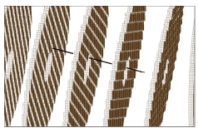
We initially looked for ions out of the tandem using a silicon surface barrier detector on the zero degree port of our switching magnet, after the 90 degree analyzing magnet. Scanning the analyzing magnet field did reveal some ions, but the results were puzzling. We were only able to see a few hundred counts per second, far fewer than expected for a 1 kHz laser pulse repetition frequency. In addition, we needed to use our high energy quadrupole triplet lens for focusing. Given the small size of the initial ion source in the laser focus, the emittance should be good enough that quadrupole focusing is unnecessary. The trajectories of the ions and the resulting energy spread on the detector seemed much broader than we would expect from a well-defined beam of ions originating from a highly localized spot in the accelerator. Finally, the time structure of the detector signals showed a far greater spread than expected. We came to the conclusion that the ions we were seeing were not those coming directly from the laser focus.
Figure 4: SIMION trajectory in spiral tube.
Simple analytical calculations and more elaborate simulations with SIMION soon confirmed that the problem lay in the Dowlish spiral inclined field tubes. More specifically, the presence of any transverse electric field during the initial stages of ion acceleration lead to the eventual collision of the ions with acceleration planes downstream (Figure 4). Since only the first couple of planes in the third tube are non-inclined, those transverse fields are certainly present in the Dowlish tubes. Any ions we were seeing on our detector were the result of some scattering or some other strange trajectory and certainly not due to the main beam. Of course, this is precisely the purpose of inclined field tubes, spiral or otherwise: to eliminate charged particles created along the acceleration path. It made them useless for our purpose, however.
Fortunately, we still had in-house the old HVEC inclined field tubes removed from the tandem in 1990 when the Dowlish tubes were installed. In particular, the first 22 planes of the old #1 inclined field tube are non-inclined and thus suitable for accelerating ions from rest. SIMION calculations predicted that the combination of an inclined field tube in the #3 position and a spiral tube in the #4 position should both allow us to extract the ions and not too adversely affect the acceleration of normal ion beams from the negative ion sources. We therefore carefully made the swap and did some conditioning and acceleration tests to confirm our expectations. Of course, the first thing we noticed is that the presence of an old aluminum acceleration tube made conditioning a much more time consuming process than with all titanium spiral tubes. Now, instead of a 7 MV machine, we have a 6 MV machine requiring considerable conditioning to achieve the higher voltages. Except for the increased conditioning time, this is not a hardship, because few if any of our recent experiments have required the higher voltage. We also have not seen any beam optics changes that could not easily be compensated for by existing ion-optical elements.

5. The Results So Far

After swapping out the acceleration tube, we immediately saw a big improvement in ion yield. In fact, we were initially confused by the large number of different ion species that showed up when we scanned the analyzing magnet. To get a better picture of everything ionized by the laser pulse, we placed a silicon surface barrier detector on a linear feedthrough just before the analyzing magnet. We inserted it into the beamline far enough to detect ions that we could steer to one side of the beam pipe but not so far as to block the laser beam traveling upstream towards the terminal mirror. The detector signal was amplified by an Ortec VT120C preamplifier and sent into an Ortec 935 Quad Constant Fraction Discriminator, with additional amplification stages thrown in as needed. Finally, the discriminator output was fed into a CAEN V1290 VME multi-hit time-to-digital converter (TDC), which has 25 ps/channel resolution. The zero time reference signal was obtained from a photodiode mounted on our optical table detecting reflected laser light from our neutral density filter. The multi-hit nature of the TDC was critical because of the numerous different ions produced by each 400 µJoule laser pulse. Our event-mode data acquisition software was thus able to histogram a composite time-of-flight (TOF) spectrum of all (up to the maximum of 16) ions for each pulse.
The resulting spectrum (see Figure 5) resembles a residual gas analyzer trace. Our background gas contains sulfur hexafluoride and hydrocarbons which are being dissociated by the laser pulse. The various fragments are accelerated by the high energy tandem tubes and appear as discrete TOF peaks. The ion beam was tuned (using the high energy electrostatic steerers) so as to maximize the total number of detector pulses appearing on an oscilloscope.
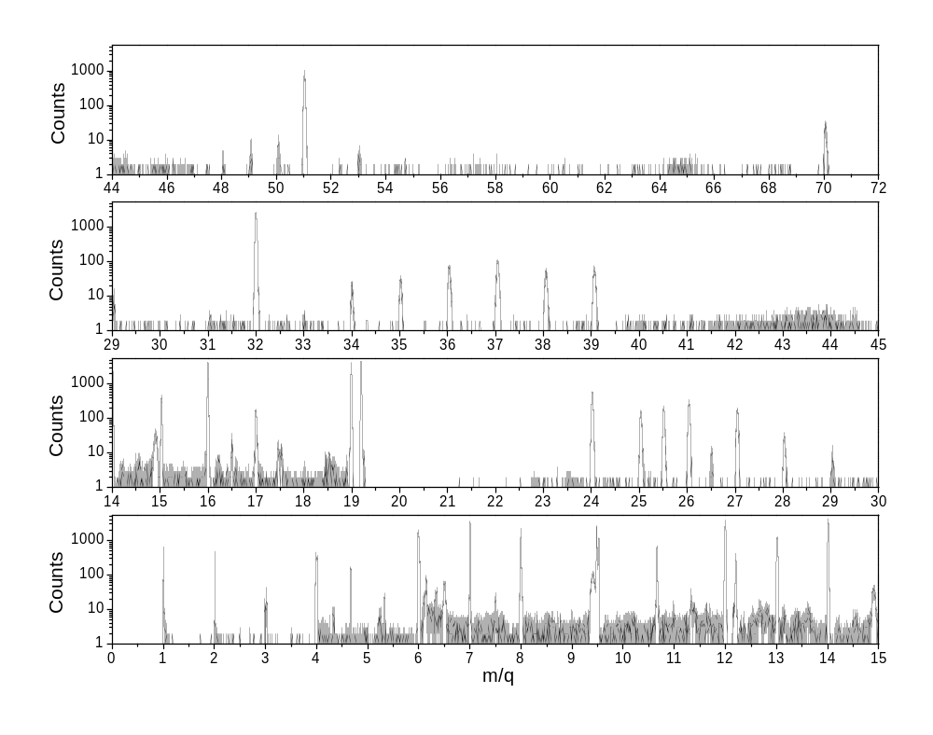
Figure 5: 400 microJoule laser on background gas.
One puzzling feature of this spectrum is the absence of a water peak, usually a prominent feature of any laser ionization spectrum of residual gas. Our background gas surely contains a significant amount of water vapor. Neither of the other likely candidates for non-dissociated molecular ions, m/q=32 (O₂⁺) and m/q=28 (N₂⁺), looked right either. The m/q=32 peak could easily be sulfur from SF₆, and there didn’t appear to be enough m/q=28 to account for the amount of m/q=14. We concluded that we had tuned the beam to maximize the dissociated molecular ion fragments, which would have a larger transverse dimension due to their initial Coulomb explosion energy, but had missed the main beam of non-dissociated molecular ions. Careful re-tuning while observing the expected position of the H₂O⁺ peak on an oscilloscope resulted in the spectrum seen in Figure 6. Now the H₂O⁺, O₂⁺, and N₂⁺ peaks are clearly dominant, as expected. Next, we opened the terminal leak and allowed some neon stripping gas into the accelerator tubes. The resulting spectrum is seen in Figure. Note that all four of the main peaks are saturated or nearly saturated, meaning there is at least one ion produced for each laser pulse.
The width of the ²⁰Ne peak is 1.2 ns, as shown in Figure. If our estimates of the various contributions to pulse width are correct, we have not yet achieved the 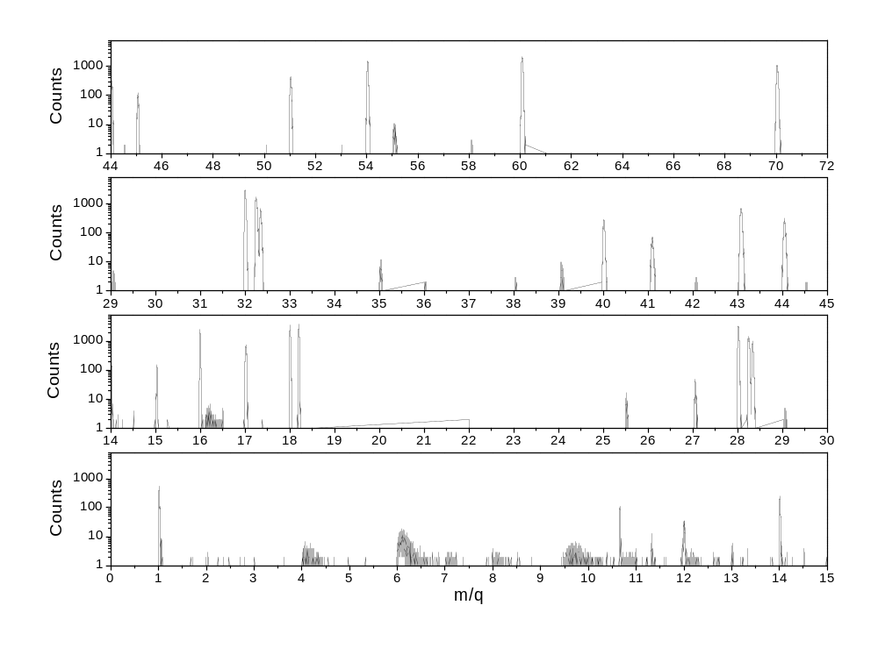
Figure 6: 400 microJoule laser on background gas, properly tuned.

minimum width possible with our current configuration. However, since we are accumulating the TOF data on an event-by-event basis, it is possible for us to construct a spectrum from the scaled TOF difference between two of the molecular ion peaks. We chose Ne⁺ and H2O⁺, dividing the TOF of each by the square root of the ion mass number before subtraction. In effect, this scales the TOF width to that expected for the difference between two proton (m/q=1) peaks. Since the tandem ripple, the largest estimated effect on the pulse width, is relatively slowly varying, all ions in a given laser pulse should be created at the same tandem voltage. Doing the scaled subtraction of TOF’s should remove the voltage ripple from the equation, while other factors, such as thermal spread and position along the confocal length of the laser beam, should be different for the two ions. The result is seen in Figure 9, with the two spectra taken at different laser intensities. The scaled widths of 67 and 118 ps are encouraging.
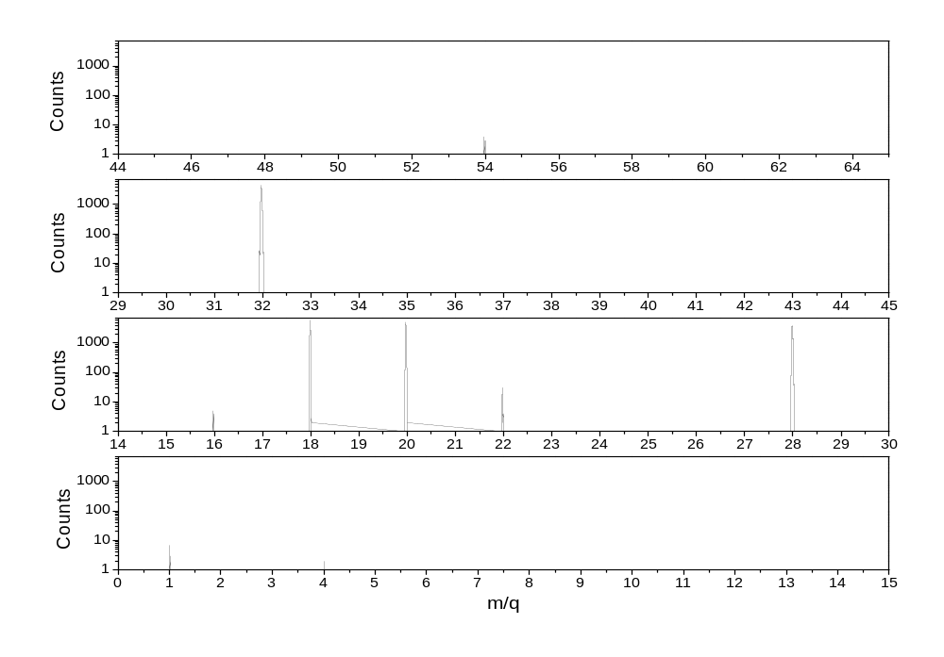
Figure 7: 400 microJoule laser on neon stripping gas.
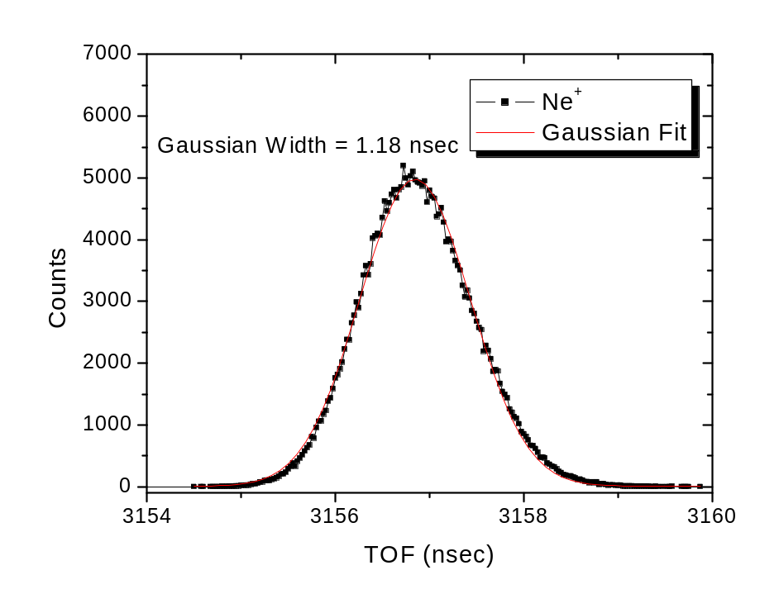
Figure 8: Neon TOF width.

6. The Next Step

We would like to find another way to measure the spread of the ion pulse for each laser shot that is not so dependent on signal processing electronics. Fortunately, we have in-house a streak camera that is capable of measuring time spreads down to a few picoseconds [7]. It operated by converting a time spread into a spatial spread via fast, triggered deflector plates (see Figure 10). The ion pulse will impinge on a thin foil and create an electron shower, which will be deflected electrostatically by a very fast set of deflection plates. The plates can be gated at a particular time so as to only deflect a certain range of TOF’s. The dispersed electron pulse (the “streak”) is imaged by a CCD. This will give us a good measurement of the pulse width within each measured laser pulse. Once we have reliable measurements in hand, we will need to do the hard work of compensating for some of the sources of pulse width (such as using the terminal voltage ripple signal to control some sort of laser delay to better match the pump ion pulse with the probe laser pulse). When that compensation is successful, and perhaps before, experiments will begin.

7. Conclusion and Acknowledgments

This project has been a highly collaborative effort, involving several different faculty and most of our technical staff. Not only have we had to stretch our newly acquired and still limited laser expertise, but we’ve learned some things the tandem that we had either never fully understood or had forgotten. Future development of the system and the subsequent experiments should be similarly enlightening.
In addition to the authors of this paper, the following members of the J. R. Macdonald Laboratory were involved in this project: Professors Pat Richard and Brett DePaola, and technical staff Mike Wells and Bob Krause. We are funded by the Chemical Sciences, Geosciences and Biosciences Division, Office of Basic Energy Sciences, Office of Science, U.S. Department of Energy.

References

- B.J. Siwick, J.R. Dwyer, R.E. Jordan, R.J. Dwayne Miller, Science 302, 1382 (2003).
- H. Ihee, B.M. goodson, R. Srinivasan, V.A. Lobastov, and A.H. Zewail, J. Phys. Chem. A 106, 4087 (2002).
- T. Kirchner, Phys. Rev. Lett. 89, 093203 (2002).
- T. Niederhausen, B. Feuerstein, and U. Thumm, Phys. Rev. A 70, 023408 (2004).
- SIMION 3D, written by David A. Dahl, Idaho National Engineering and Environmental Laboratory.
- B.L. Qian, H.E. Elsayed-Ali, J. Appl. Phys. 91, 462 (2002).
- J. Liu, J. Wang, B. Shan, C. Wang, and Z. Chang, Applied Physics Letters 82, 3553 (2003).
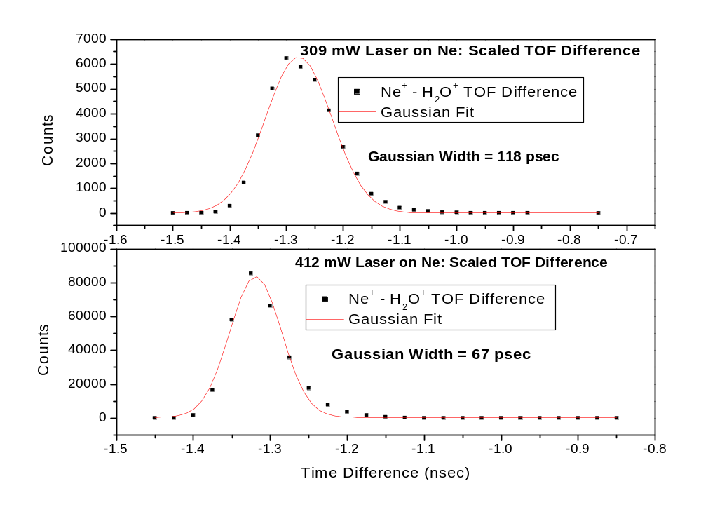
Figure 9: Scaled TOF difference.

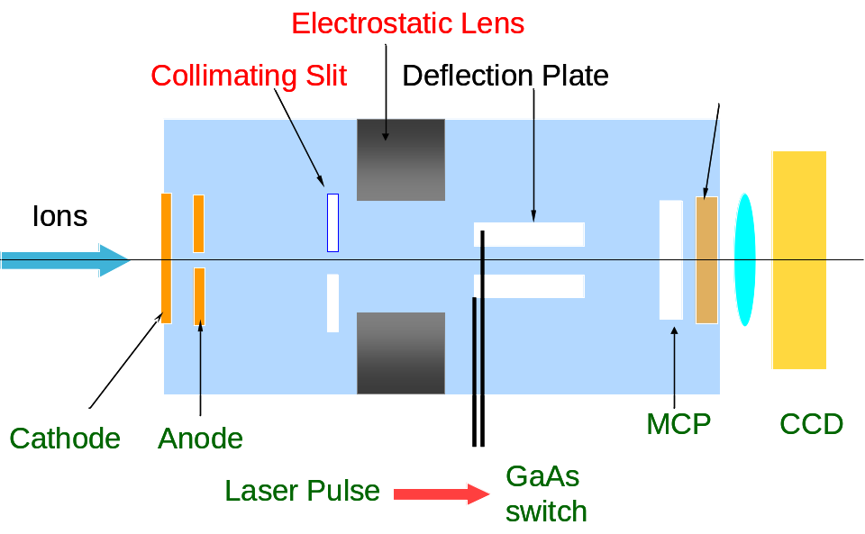

Figure 10: Streak camera.

